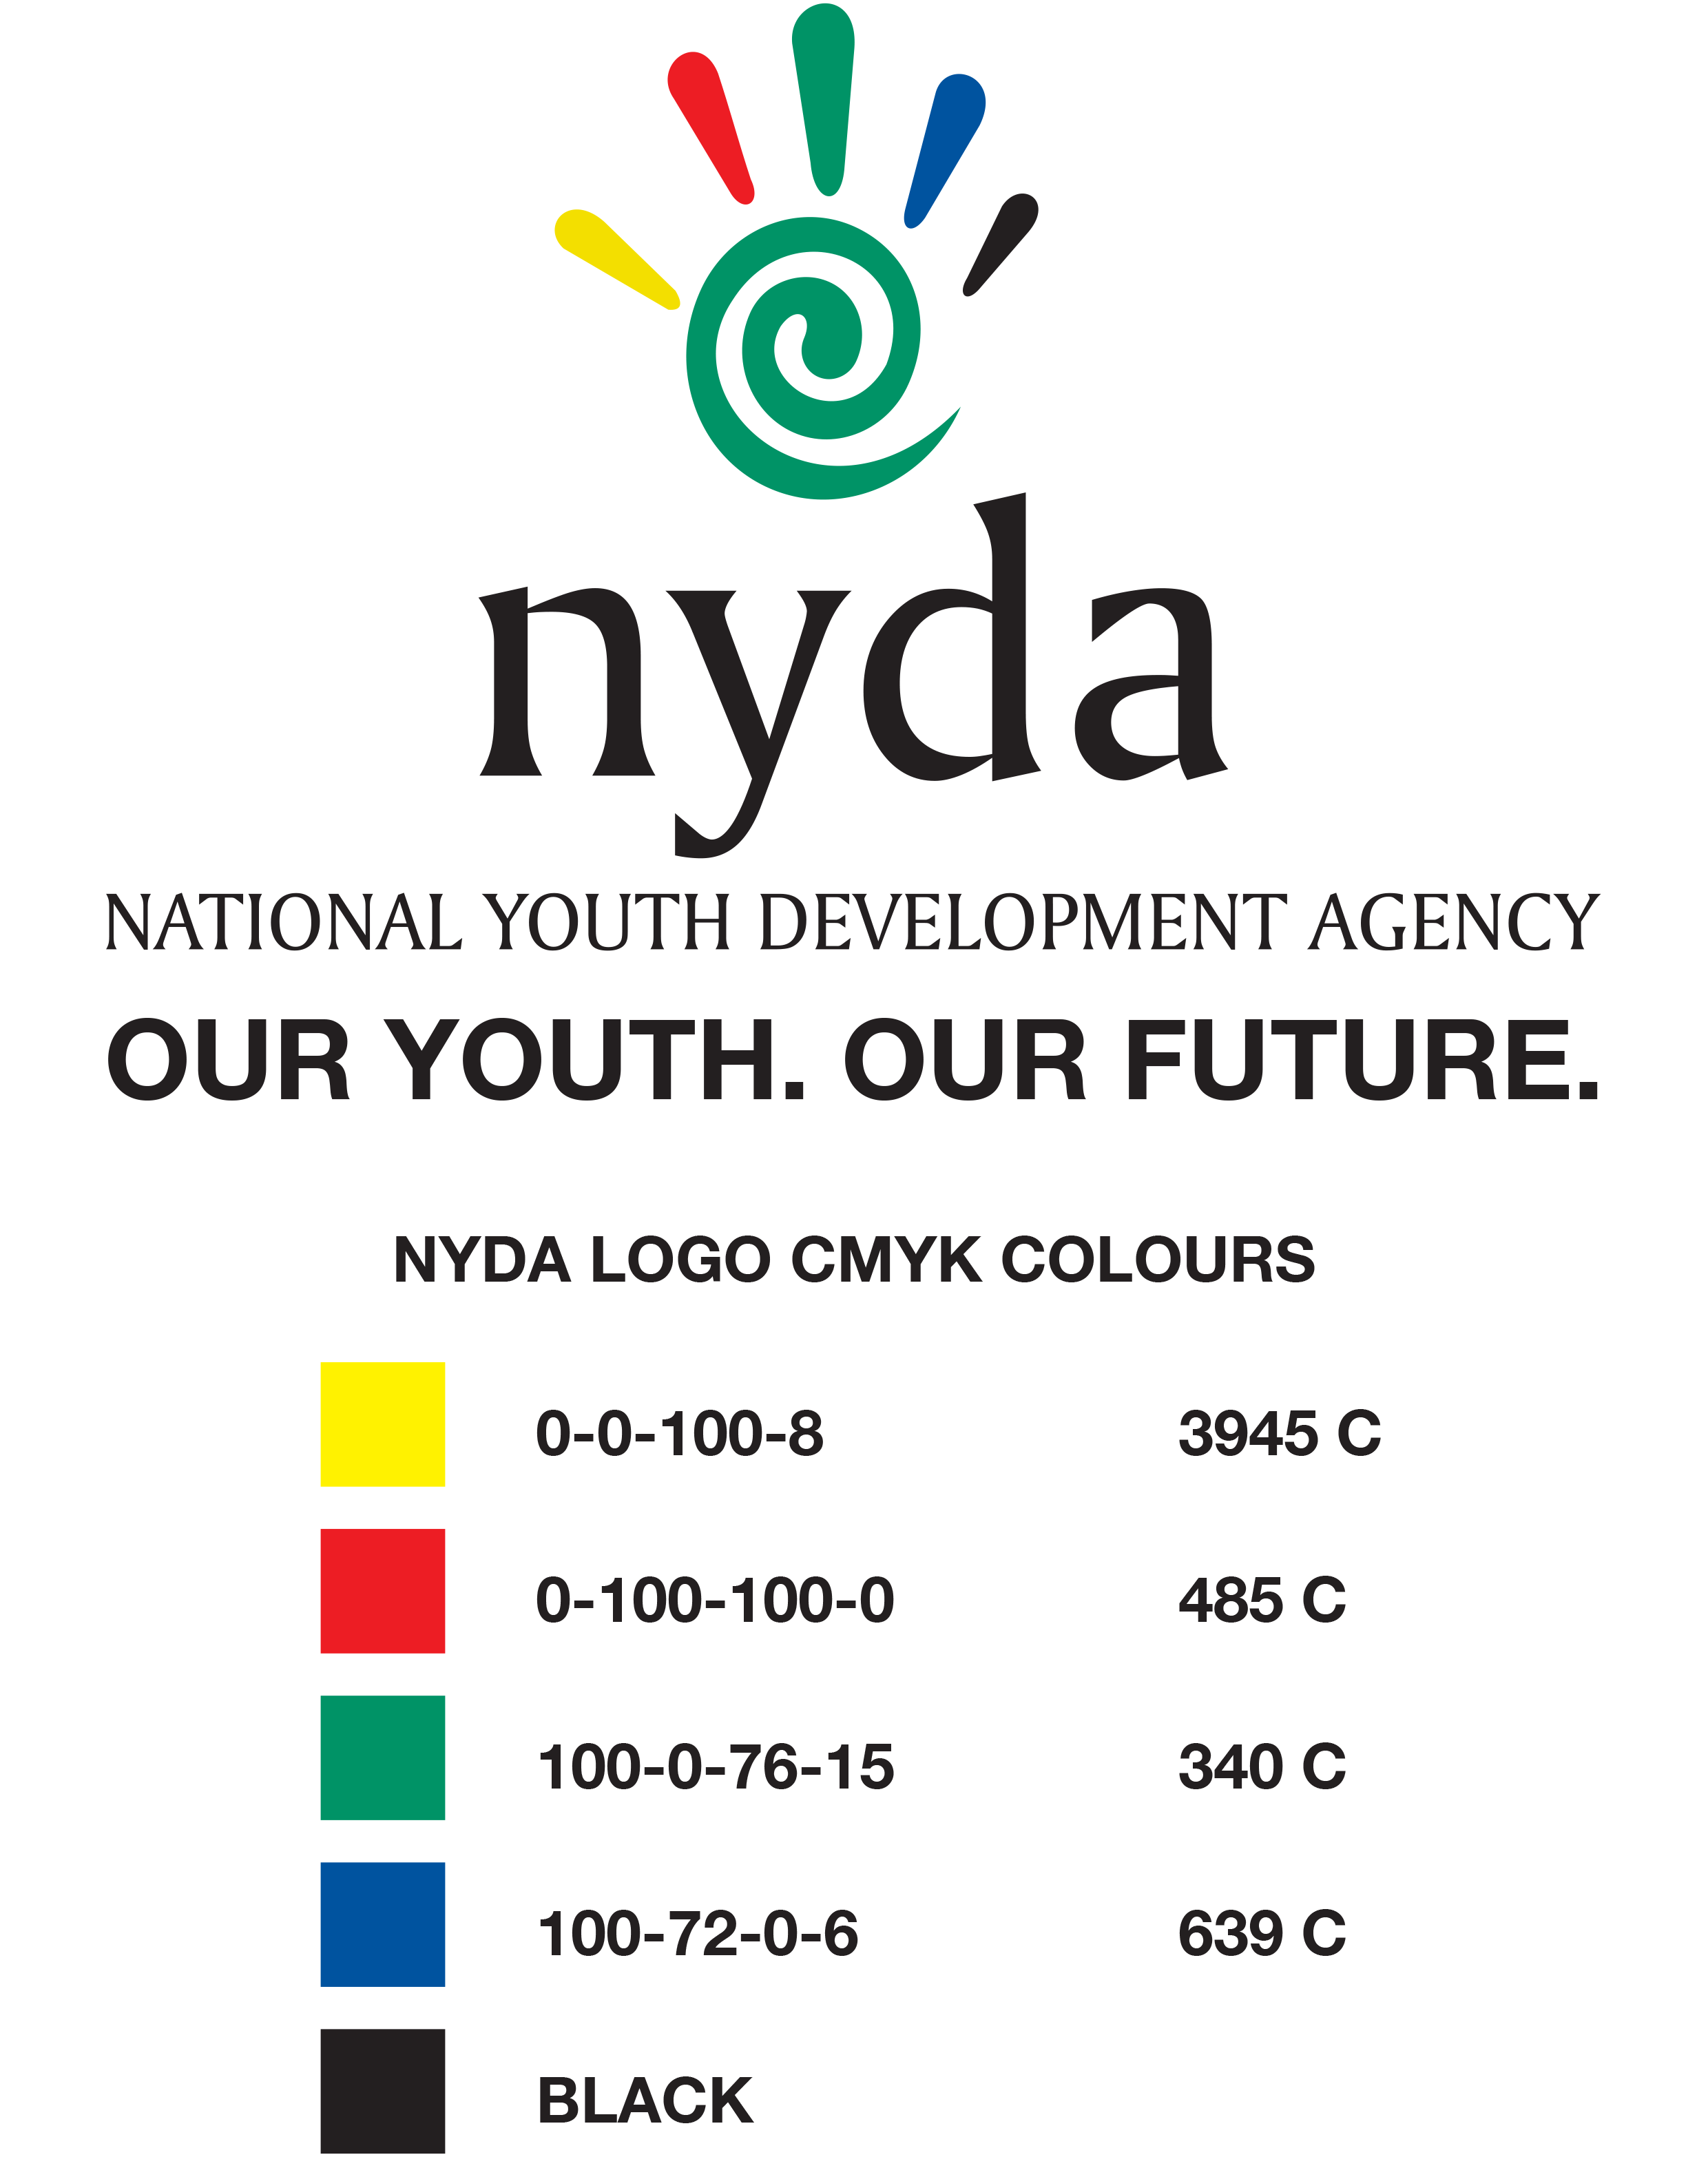

COVID 19 YOUTH RELIEF FUND APPLICATION FORM
- APPLICATION FORM SUBMISSION (FOR OFFICE USE ONLY)
Date of submission: |  | Submitted by:
Received by: |  | Signature :
Previous funding GR# |  | Funding date
Three Months bank statements |  | Enterprise 100% youth owned

- PERSONAL INFORMATION
Surname: | Names as appears in Identity Document (ID): |  |  |  | Gender:
 |  |  |  |  | Male
 |  |  |  |  | Female
Date of Birth: | Identity No:
*Race Group: | Africans | Indians | Disability | Yes
 | Coloured | Whites |  | No
Business Address: | Postal Address: |  | Tel. No. :  Cell No.:  E-mail:

- JOBS SUSTAINED
 | PERMANENT JOBS |  |  |  | TEMPORARY |  |  |  | SHORT TERM
 | Male | Female | Youth | Disable | Male | Female | Youth | Disable | Male | Female | Youth | Disable
African
White
Indian
Coloured
Total

- APPLICATION SUMMARY
- Provide summary description of the business:

- Describe the impact of COVID-19 on the business

- Describe the nature of support required and what are the funds to be used for

- Provide any other relevant information to support your application

